CSCI 5709

Advanced Topics in Web Development

Assignment 1 (Individual)

Name: Rishabh Domadiya

Banner ID: B00902679

Email: [rs582144@dal.ca](mailto:rs582144@dal.ca)

**USER EXPERIENCE AND TASK FLOW**

**Feature:**  Housing Analysis

**Tasks Included:**  Add Review, Edit Review, Analytics

**ADD REVIEW TASK FLOW**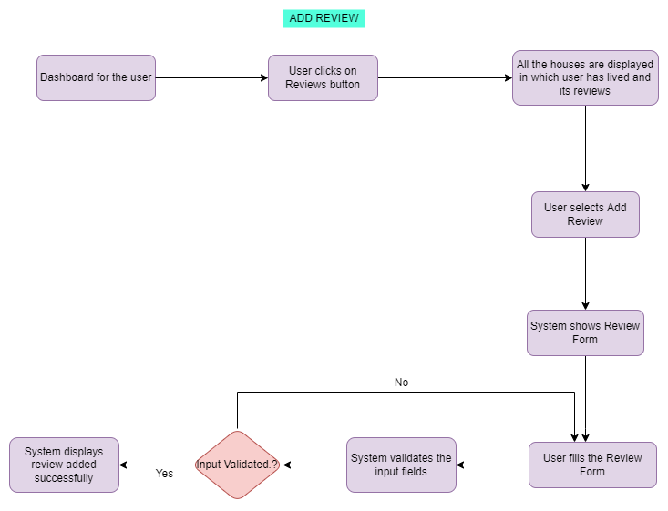

Figure 1 Add Review Task Flow

**EDIT REVIEW TASK FLOW**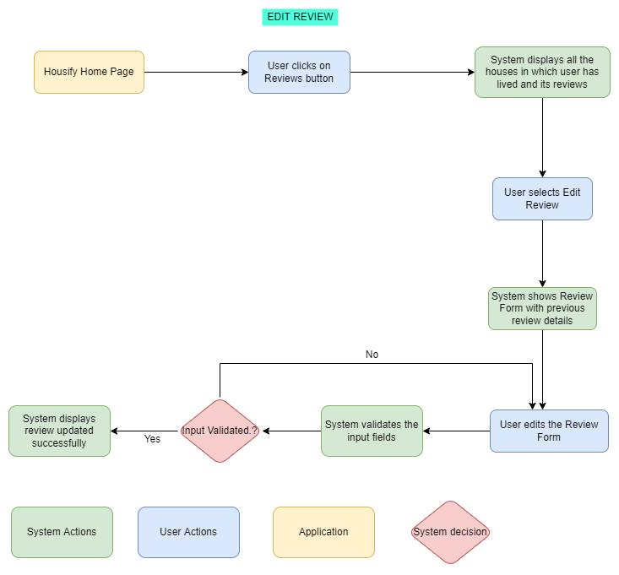

Figure 2 Edit Review Task Flow

**ANALYTICS TASK FLOW**

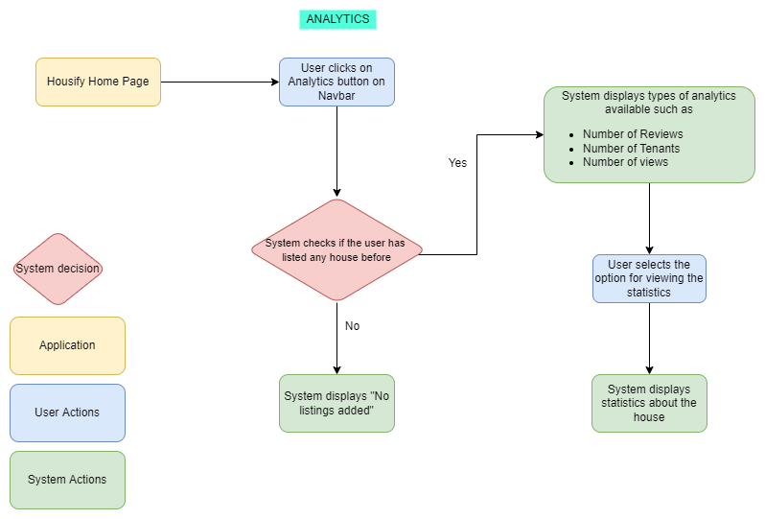

Figure 3 Analytics Task Flow

**LO-FIDELITY PROTOTYPE**

**Title:** Reviews

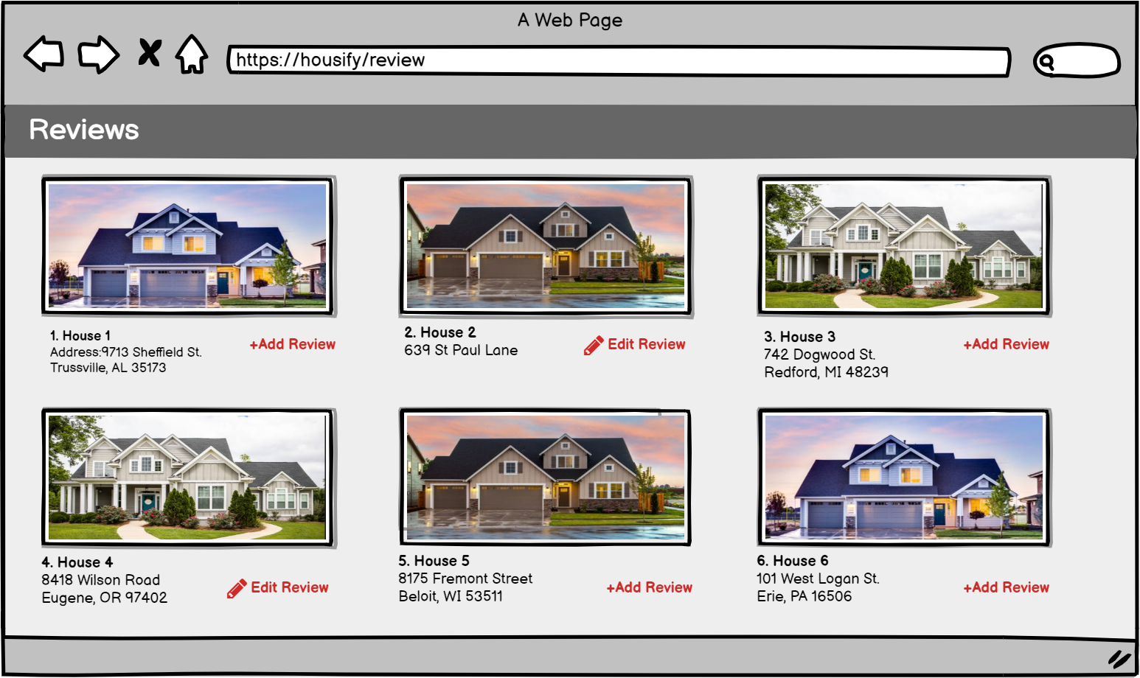

Figure 4 All reviews wireframe

**Title:** Add Review

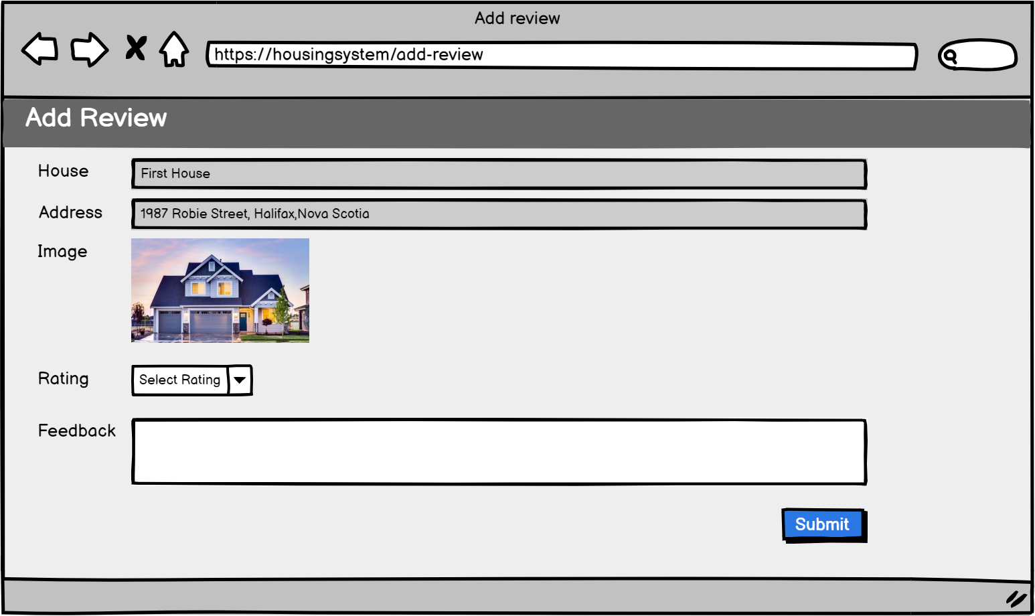

Figure 5 Add Review Wireframe

**Title:** Edit Review

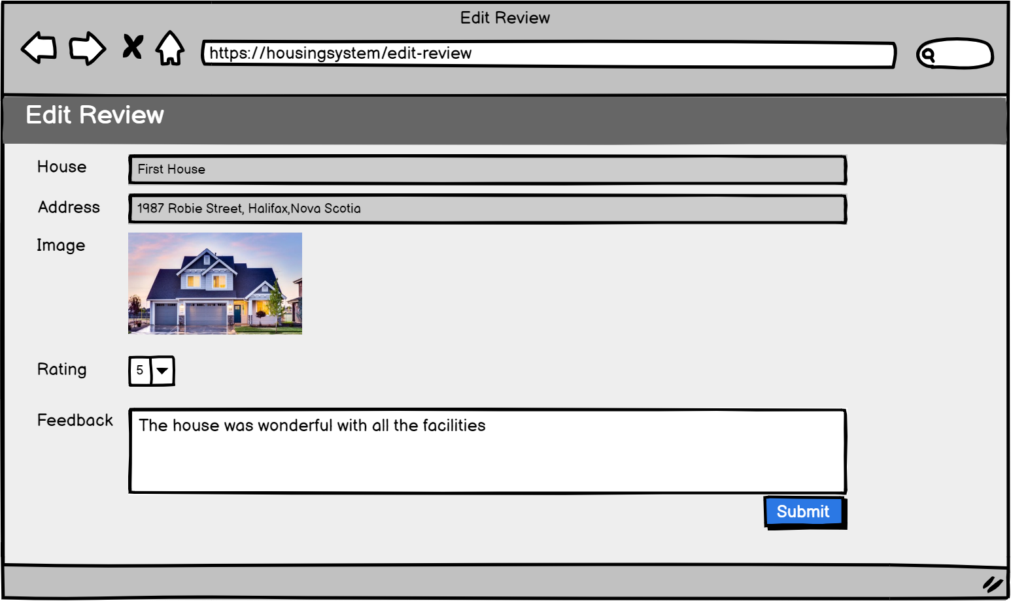

Figure 6 Edit Review Wireframe

REFERENCES/ SOFTWARES USED

[1] “Flowchart Maker & Online Diagram Software”, App.diagrams.net. [Online]. Available: <https://app.diagrams.net/>

[2] “Balsamiq. Rapid, Effective and Fun Wireframing Software | Balsamiq”, Balsamiq.com. [Online] Available: https://balsamiq.com/